Easter Farm



Team Raspberry

A single-player Arcade Game Project for

Telerik Academy 2015, course OOP

Team members:

* Svetla Ivanova – (svetlai)
* Dobromira Boycheva – (dobromira.boycheva)
* Veselin Tsvetanov – (veselints)
* Simeon Georgiev – (simeon.georgiev)
* Kiril Kolev – (kiko81)
* Hristo Slavov – (h.slavov)
* Hristiyan Andreev – (Hristiyan_Andre)
* Svetlin Krustanov – (bai.gundi)
* Abelina Georgieva – (abelina)

Github : <https://github.com/TeamRaspberry-Telerik/EasterFarm>

Game Description:

You are a farm manager. You have special animals - lambs, hens and rabbits eating raspberries and blueberries all over the farm. There is a Market where you can exchange eggs, cookies and milk for berries, cocoa, flour, basket, ribbons needed to exchange for special presents in the present factory to handle this special holiday EASTER !!! Sounds great until…the villains sneak in the farm trying to eat your livestock. Wolves and foxes are running within the farm trying to spoil your very special holiday!

Game logic:

* Your animals are running randomly in the farm. Wolves and foxes are aiming directly at you animals! You have a **GUN** and you main task is to **SHOOT** those nasty **VILLAINS**! But if you are not very precise, you can shoot your precious animals!
* You have recipes for the presents in the present factory, and when you collect enough eggs, milk and cookies go to the market and buy the exact things needed to exchange for
* EasteRabbit (Choco, with Ribbon, with Trophyegg )
* EasterBasket (with Ribbon, with Cookies, with Choco eggs)
* EasterFood (Kozunak, Cookie, Choco egg, Cheverme).

Game Goal:

* Make this **VERY** **SPECIAL** **HOLIDAY** for you and for everyone around you!

HAPPY EASTER!!!

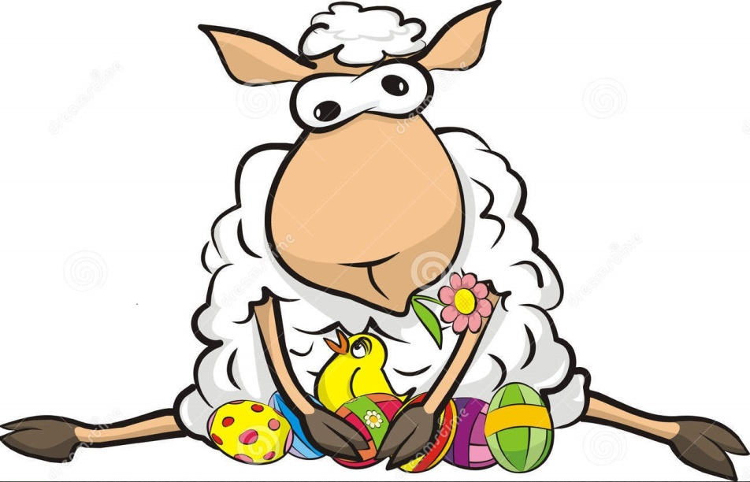

Class diagram:

* Important classes and interfaces

